**Name: Fabian LeFevre**

**Date: 9/11/18**

**Homework 1:**

1. Please add the **three screenshots** from the lab section and insert them below.

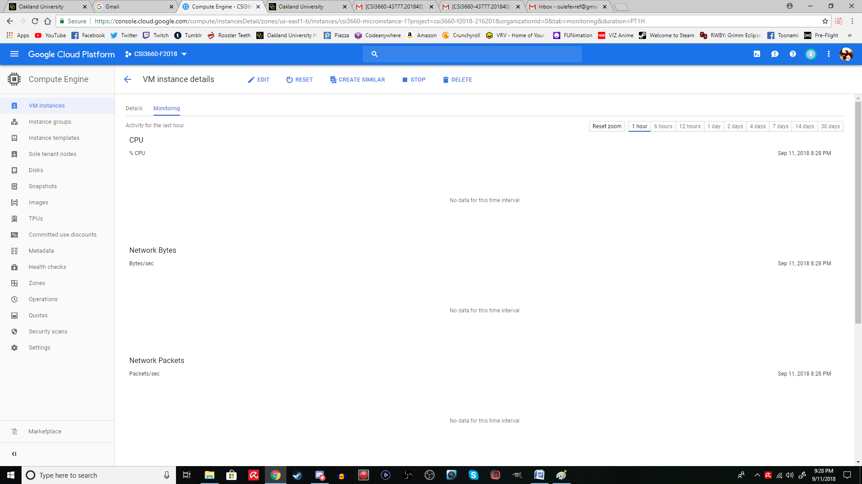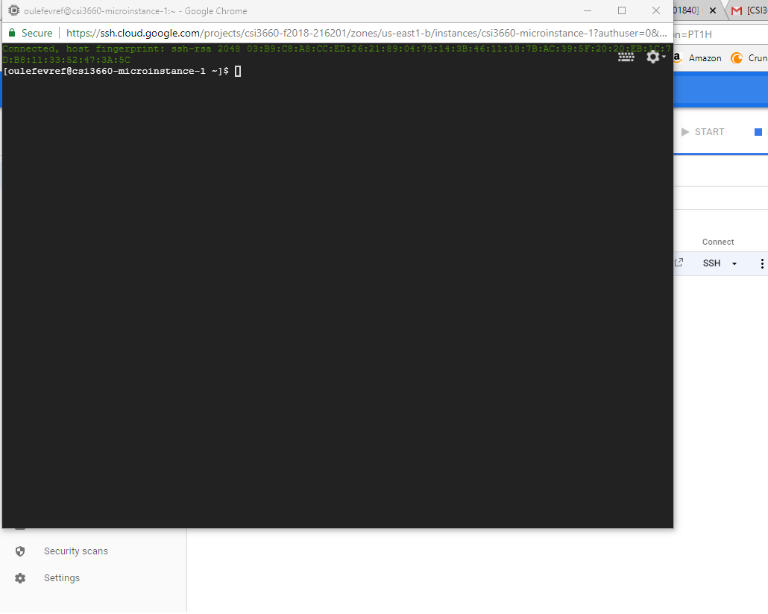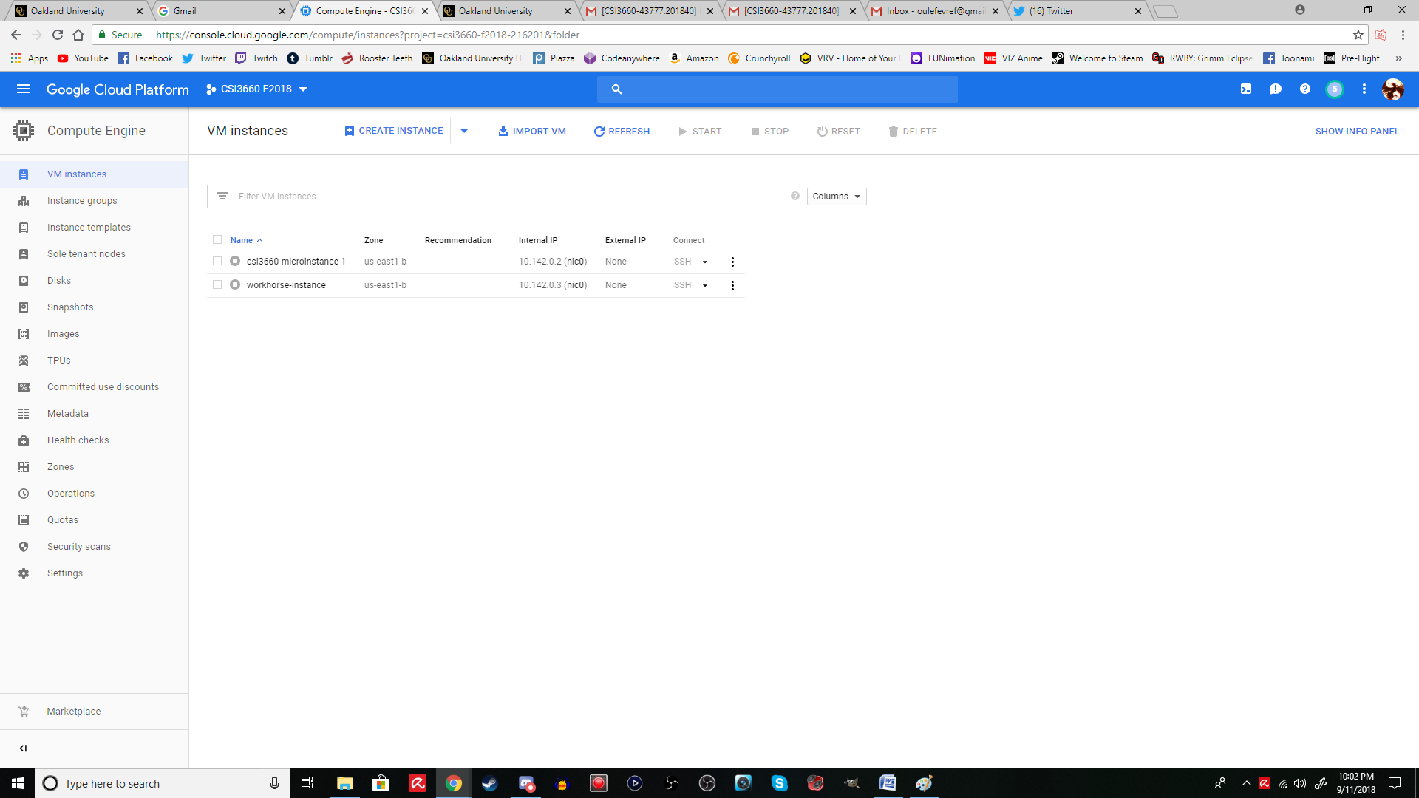

1. Describe how much free space and total space is available on your virtual machine’s hard drive (the micro-instance). Also, what is the name of your hard drive on the system (it can be found in that command you ran)?

**Free Space: 29GB**

**Total Space: 30GB**

**Hard Drive Name: /**

1. What protocol are you using to connect to your remote Google Cloud server? Why is this better than a protocol like telnet? (You may need to look up telnet).

**SSH: Secure Shell**

**Telnet just establishes a connection, SSH creates a secure connection**

1. What are **two** benefits of using Google Cloud over, say, our local VM server with CTO?

**Ease of access**

**Easy to setup**

1. Why do you need to stop your VM instance when you are done?

**It costs money to keep it running. So, it will eat the funds that are currently in my billing.**

1. If you wanted to connect to your Google Cloud VM, what is the single IP address for each that you would connect to if you are **outside** of the Google Cloud infrastructure (e.g., you are trying to visit a website you setup on the VM)? For this, take a long hard look at the VM instance details...

**The external IP Addresses, which are not available when the instances are turned off.**

